**ITA0448 – STATISTICS WITH R PROGRAMMING FOR VECTORIZED EXPRESSIONS**

**SUBMITTED BY: DEVADARSHINI J REG NO: 192124092**

**DATE: 24/03/2023**

1. Write a R program to Create the following details:
   1. x= sample(-50:50, 10, replace=TRUE).and print the value of x
   2. To create a sequence of numbers from 20 to 50 and find the mean of numbers from 20 to 50 and sum of numbers from 20 to 50.

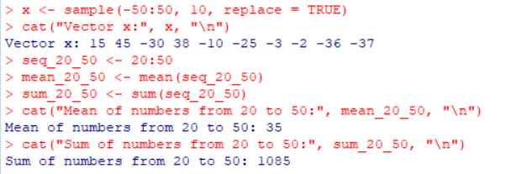

1. To create an array of two 3x3 matrices each with 3 rows and 3 columns from two given two vectors.vector1 = c(1,3,4,5) and vector2 = c(10,11,12,13,14,15)
2. Print vector1, vector2
3. Print new array

